AI Assisted Coding
Assignment - 02

SYED MASHOOD ADNAAN
2303A54059
Batch: 47_B

Lab 2: Exploring Additional AI Coding Tools beyond Copilot – Gemini (Colab) and Cursor AI
Task 1: Statistical Summary for Survey Data
Scenario: You are a data analyst intern working with survey responses stored as numerical lists.
Prompt:
Write a Python function that takes a list of numbers and returns the mean, minimum, and maximum value
Logic: The function takes a list of numbers and finds the average, smallest, and largest values.
It then shows these results as a simple summary of the data.
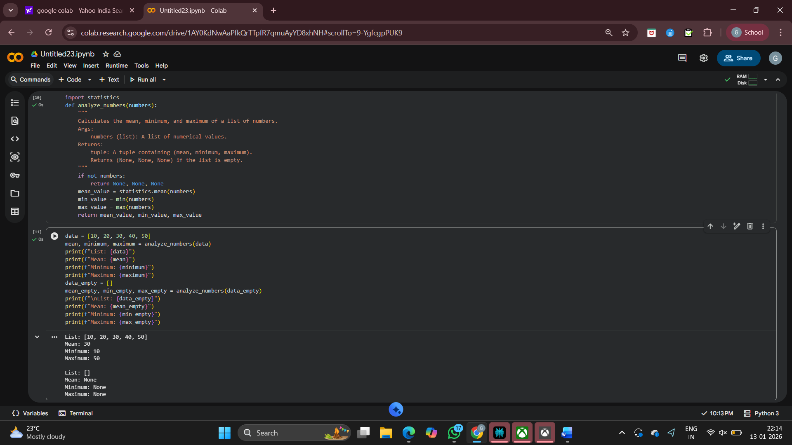

Task 2: Armstrong Number – AI Comparison
Scenario: You are evaluating AI tools for numeric validation logic.
Prompt (Gemini):
Write a Python program to check whether a given number is an Armstrong number.
Prompt (Copilot):
Write a Python program to check whether a given number is an Armstrong number.
S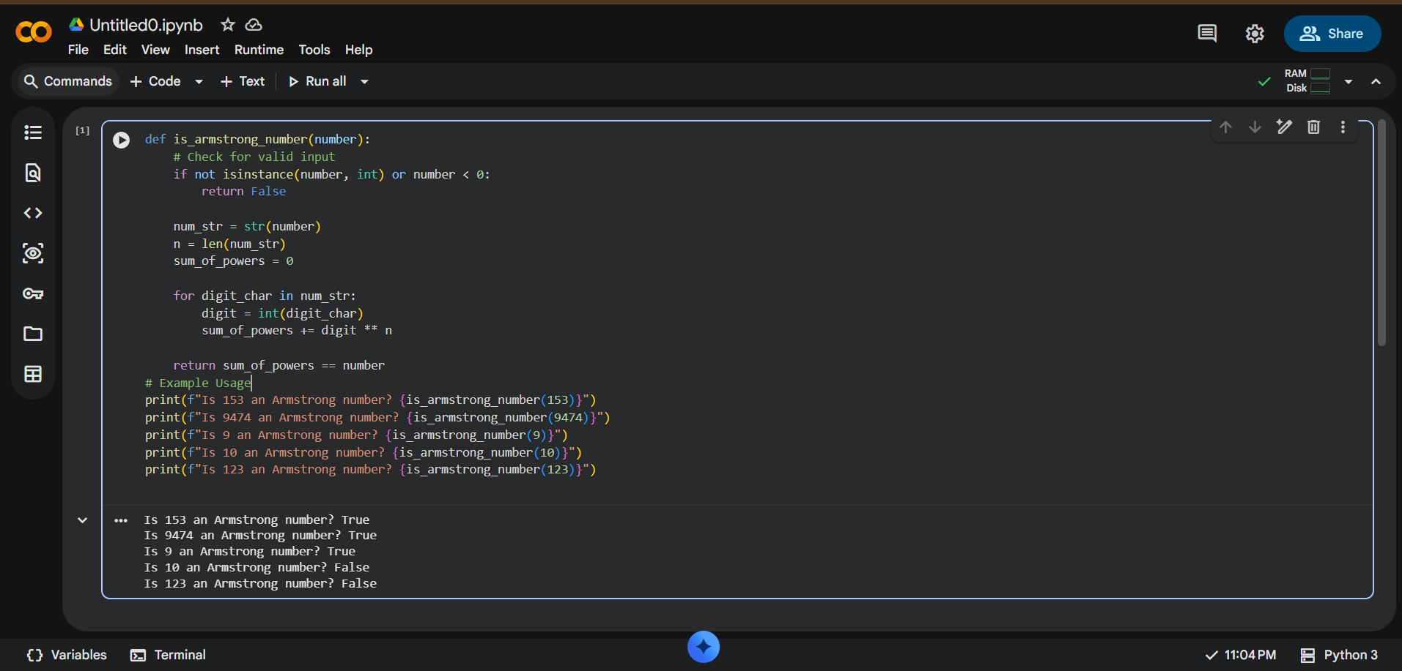

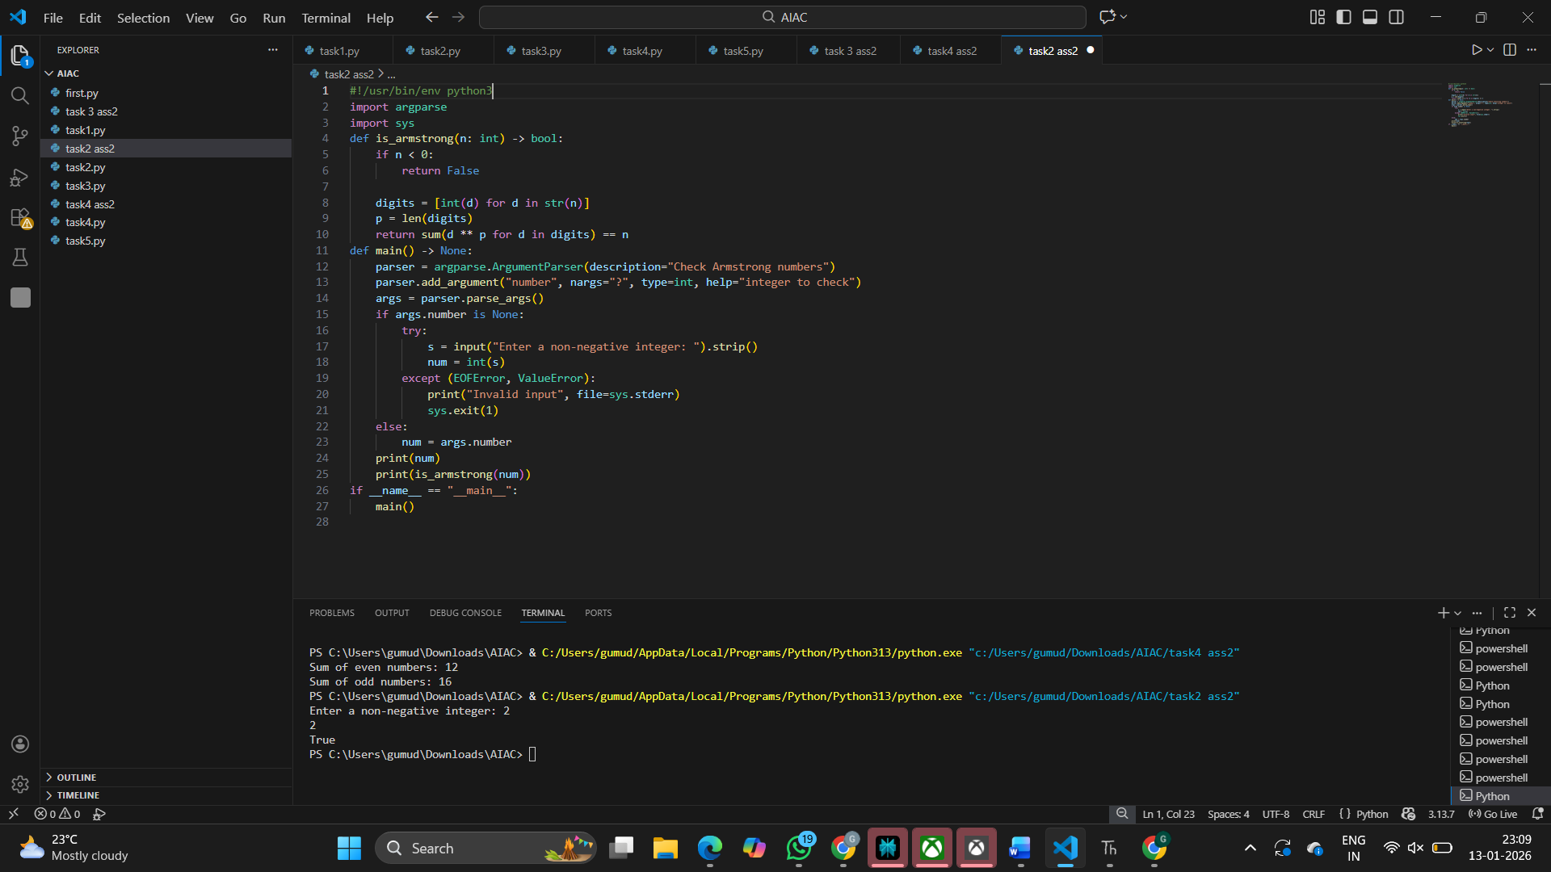
Side-by-Side Comparison Table :

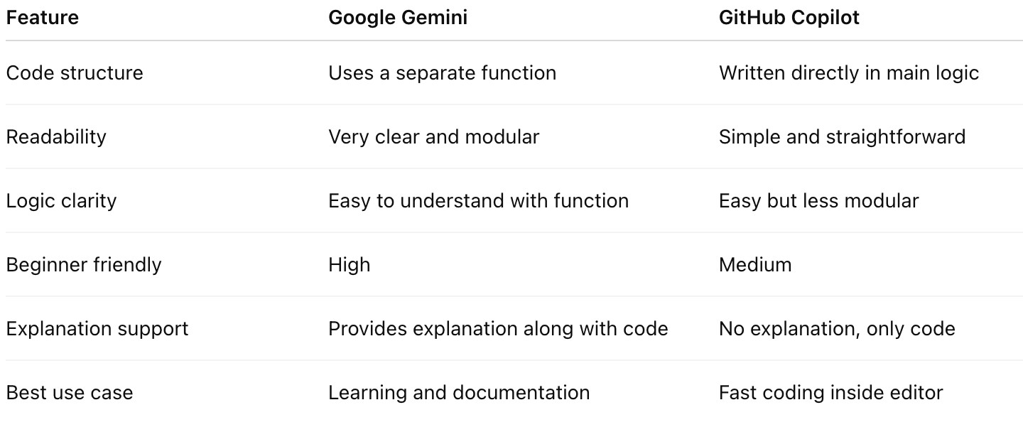

Task 3: Leap Year Validation Using Cursor AI
Scenario: You are validating a calendar module for a backend system.
Prompt:
Write a Python program to check whether a given year is a leap year.
Logic :
The code had simple logic to check leap years.
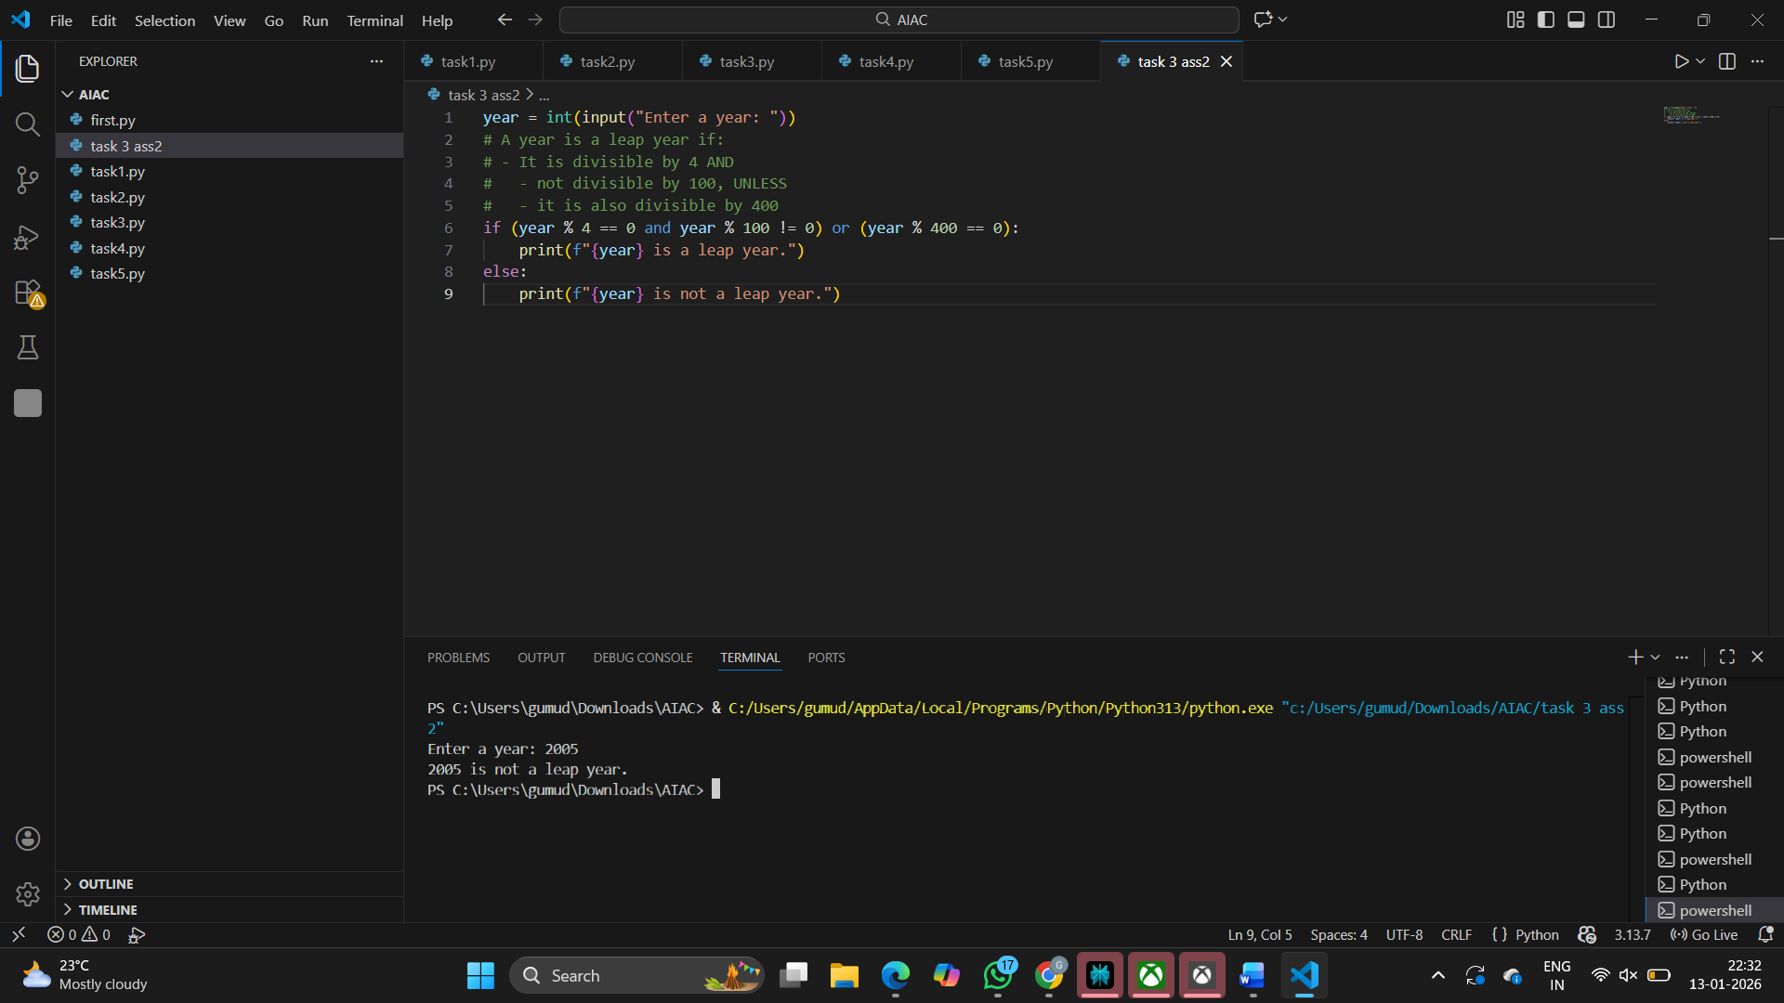

Task 4: Student Logic + AI Refactoring (Odd/Even Sum)
Scenario : Company policy requires developers to write logic before using AI.
Prompt : Refactor this Python code to improve readability and efficiency

Student Code:
T = (1, 2, 3, 4, 5, 6, 7)
even_sum = 0 odd_sum = 0
for i in t: if i % 2 == 0:
even_sum = even_sum + i
else:
odd_sum = odd_sum + i
print("Sum of even numbers:", even_sum) print("Sum of odd numbers:", odd_sum)
AI Code:
